Ezra Spiro, “Flute”
Using a favorite quotation from an essay or book you have read in the last three years as a jumping off point, tell us about an event or experience that helped you define one of your values or changed how you approach the world. Please write the quotation at the beginning of your essay.
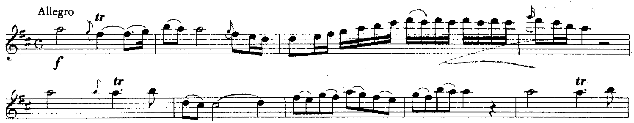
How can one describe what it is like to play with three of the best musicians in the world? Every time I read this quote from Mozart’s Flute Quartet in D Major, I relive the time I played it with my aunt and uncles Marijn, Henk, and Floris when I visited them in the Netherlands last summer. The thirty minutes were not only the highlight of my trip, but also the best thirty minutes of my twelve years playing flute. Most importantly, the experience and the piece showed me the benefits of working with the best.
Henk and Marijn are the first and second violinists in the Royal Concertgebouw Orchestra in Amsterdam, and Floris is the Principal Cellist for the Rotterdam Symphony Orchestra. I had thought that my best experience playing flute was when I had the opportunity to join my school’s symphonic band in Carnegie Hall, but my short experience with my talented aunt and uncles was more remarkable than I could have imagined.
So what made their playing so special? Their tone and interpretation of the music was extraordinary. The best recording in the world on the most expensive speakers would have sounded amateur in comparison. When I played along, it felt like the greatest piece of music I had ever played. Simply by making music with them I felt that my ability went far beyond what I had previously thought possible. To sit back, and hear their melodies and countermelodies felt like heaven—to play along was otherworldly.
Flying home, I reflected on why that half hour of Mozart had meant so much to me. I gleaned more musical insights concerning the phrasing and the jocular tone of Mozart from my debut performance with my Dutch relatives than I could possibly have learned from weeks of study in Tucson. Why? Because some of the best musicians in the world allowed me to experience their brilliance. As I thought about it more, I realized something important: it is an extraordinary privilege to study with the best in the world, and that is why Princeton is my first choice. I can think of nothing better than to be able to study and discuss economics with Paul Krugman (my father tells me that I had dinner with him once when I was a baby, but now that I’ve studied his macroeconomic theories, I’d like a second chance). Similarly, to study politics with Robert Keohane or Andrew Moravcsik, whom I also met in diapers (I was the one wearing them), would be unlike any other experience that I could aspire to.
When I ask my dad about the time he spent getting his undergraduate and doctoral degrees at Princeton, and he tells stories about the professors he befriended, the unbelievably accomplished scholars who taught him, and what he often describes as the most incredibly fun yet intellectually stimulating time of his life. Indeed, Princeton is the only university in the world in which these “Henks and Marijns” can be found in every field, and is the only university where these top professors take the time to “play Mozart” with their undergraduate students, as if they were all their nephews. I’ll bring my flute.

Ezra Spiro, UHS 2009

